Eligibility for forest schools

If your child is three then they are immediately eligible for the forest school experience.

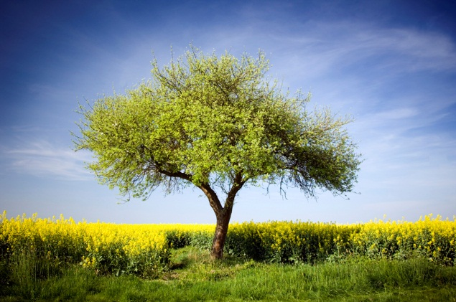

There will be a consent form to be completed and signed; a full explanation of what your child will experience will be given by our level 3 forest school co-ordinator Jan Parker. Your child will need to be out of nappies (unless covered by our special circumstances)

